

# **UNIVERSITY OF WASHINGTON**

**BOTHELL CAMPUS**

**Final Report**

Pressure-Sensitive Carpet

**Professor:** Seungkeun Choi

**Students:** Johnny Marques da Silva Fabricio Campidelli Gozzo

Joshua Yang

**Bothell-WA**

**2015**

**1. Introduction**

By integrating mats, sensors and a microcontroller, we built a Pressure-Sensitive Carpet. The systems has two important features: portability and customization. Warning areas can be easily programmed and it can be placed anywhere and operate. Using a process called progressive scanning, the microcontroller Arduino is able to read all the outputs using less hardware. The graphical interface has an important feature in order to show which sensor is being activated.

**2. Survey**

Farunhofer IFF has a pressure sensitive flooring that integrated tactile sensor systems. Tactile sensor systems uses piezo resistive polymer composite transducers with patented matrix design to measure the pressure distribution over an area with spatial resolution. This allows the flooring have customizable warning areas. 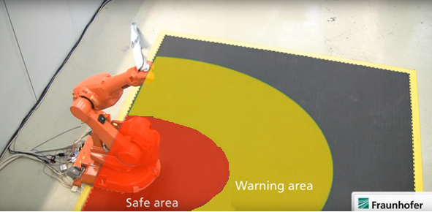

Figure 1: Tactile Sensor Pressure-sensitive flooring

The flooring is connected to a robot and when a pressure is detected in the warning area the robot operates slowly. When a pressure is detected in a safe area, the robot completely stops. To improve the current systems we have increased the portability of this technology by implementing it in to a cheap foam mats. Also, we have included a relay and a buzzer to alert when pressure is detected in a warning area. Our system also has a spatial resolution and is customizable warning areas. The mat can be moved and placed anywhere and also connect with multiple mats to cover up a different size of areas.

**3. System Overview**

The sensors system is constituted of a mat with force sensors that is read by an Arduino controller, which activate a relay to communicate digitally to the machine asking it to stop and also signalize it with a buzzer and LED. The Arduino program is used to select the desired sensor to turn on the output (relay, LED and Buzzer). An open source program interface in the PC is used to analyze the sensors communication.

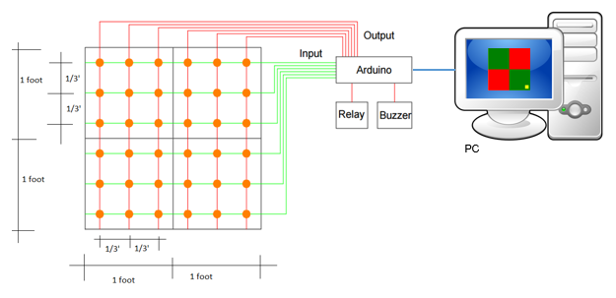

Figure 2: System Overview

3.1 Mat

The mat is disposed by 36 force sensors in a 10cm array distant from each other. Each sensor is punctual and with the distance between them and can detect a feet of an adult being human.

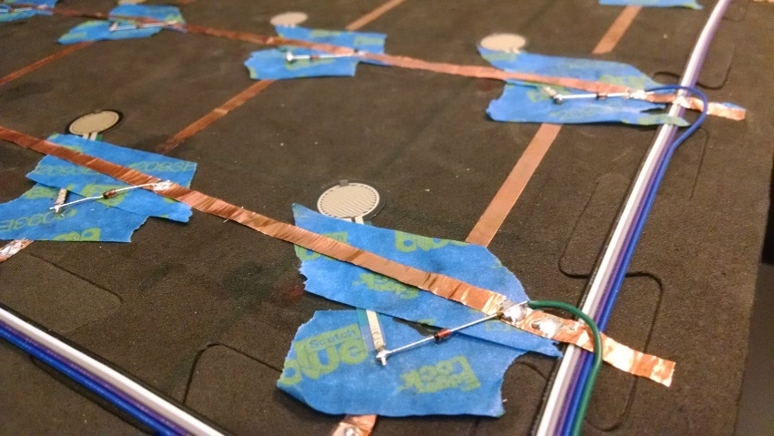

Figure 3: Sensor Connections

3.1.1 Sensors description

Manufacturer: TAIWAN ALPHA

Model: MF01-N-221-A01

Table 1: Sensor data

|  |  |
| --- | --- |
| Actuation Force | 30g |
| Force Sensitivity Range | 30~1000g(0.3~9.8N) |
| Force Resolution | Continuous(Analog) |
| Stand-Off Resistance(Unloaded) | >20MOhm |
| Response Time | <1ms |
| Life Cycle | 1 million |
| Force Repeatability (Part To Part) | ±20% |
| Operation Temp. | -20ºC to +70ºC |

3.1.1.1 Complementary information by test

The sensor was tested using an ohmmeter, and was able to find out that resistance greater than 20MOhm which was considered as open circuit by the instrument since its maximum measurement is 20MOhm. It was also possible to measure the minimum resistance of the sensor, which was applied the maximum force on it and measured a resistance less than 1kOhm (around 0,9kOhm).

3.1.2 Sensors schematic

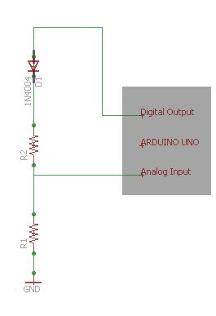 Each sensor is disposed such in the schematic beside. The R1 is a 200kOhm resistor and the R2 is the force sensor resistance. The Arduino power its digital output with 5V. The diode used decrease the output around 0.5V. The 4.5V left goes through the resistors R1 and R2. When the resistance in the force sensor is maximum, greater than 20MOhm, the circuit is considered open and the Arduino read the GND (0V). When the resistance in the force sensor is minimum, less than 1kOhm, most of the tension is over R1 because R1 is 200 times greater than the force sensor and the Arduino read 4,5V. The Arduino analog input reads 0 to 5V and write 0 to 1023 proportionally in a memory. 4.5V in the analog input is saved as 922 in the memory.

Figure 4: Sensor Schematic

This circuit characterize a digital system, where when the force in the sensor is its maximum (1kgf) the analog input is 922, and when it is less than 1 kgf the analog input is 0. After in the Arduino logic program all analog input greater than 900 is converted to a value 1 (sensor activated) and less than that is converted to a value 0 (sensor not activated).

3.2 Arduino

The Arduino UNO used, is open source board with a ATmega328P microcontroller. It has 14 digital pins that can be input and output and 6 analog inputs, both with maximum voltage of 5V. To power the Arduino is used a 9V power supply or by USB cable. The program to configure it is also open source and use the program language C++. The upload of the program is made by USB.

3.2.1 Connections Components – Arduino

The connections between the mat and the Arduino is made by flat cable. It has 6 wires for sensors power supply, 6 wires for output (tension relation between the resistors) and 1 wire for GND. All components are built in the mat. The buzzer and relay with LED is plugged in the breadboard and connected to the Arduino by wire.

3.2.2 Communication Arduino – PC

The communication between the Arduino and the PC is made by USB cable type B and A.

3.3 Buzzer and Relay components

The buzzer is a board component with 3 pins, which are the power supply (5V and GND) and the signal. The signal must be oscillatory, such the PWM output of Arduino.

The relay is also a board component with 3 pins, with the same pin configuration of the buzzer. The signal must be 5V to turn on and 0V to turn off.

3.4 Interface PC

The open source program used to configure the mat is “Virtual Arduino Screen” by Nick Steen. It is a drawing software controlled by the Arduino. It uses the same communication to upload the program to the Arduino. The drawing made by the program was the mat activated in yellow and the areas that activate the relay and buzzer. In red areas, the sensor activate the relay and buzzer, and in green areas does not.



Figure 5: Graphical interface

**4. Test Results**

The experiment was made to determine sensitive area of sensors under foam mat material. In order to do that a sensor was placed under the mat and was tested several times using the strength of a hand as it is shown in the Figure 6.

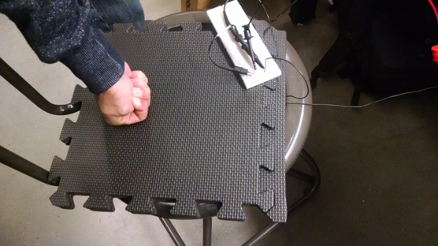

Figure 6: Area testing

The table 2 shows a table of test results as well as the number of sensors needed to cover a whole area of 4 square feet.

Table 2: Table of parameters of implementation

|  |  |
| --- | --- |
| Area Covered per Sensor | 12 ${cm}^{2}$ |
| Distance between sensors | 10 cm |
| Number of sensor – 4 square feet | 36 |

The distance between the sensors guarantees that any person’s foot, any size, will be detectable.

After implementing all 36 sensors on the mats and programming the Arduino it was tested to ensure that all sensors were working as intended. Figure 5 shows the result where the green parts are the desired areas (sensors in this area are on). The red parts are undesired areas where no sensors are on. If a person steps on the green area the buzzer and the relay would turn on. The same doesn’t happen on the red areas.

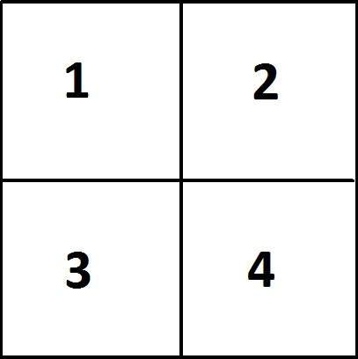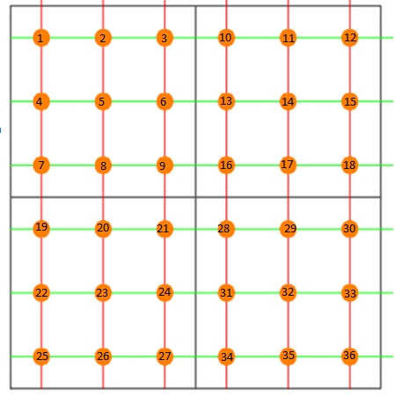

Figure 7: Label of active area and sensors.

Table 3: Test results of final product

|  |  |  |  |  |  |
| --- | --- | --- | --- | --- | --- |
| Active area | Expected result | Sensor  1 - 9 | Sensors  10 -18 | Sensors  19-27 | Sensors  28 -36 |
| 1,2,3,4 | All ON | ON | ON | ON | ON |
| 1,2 | 1-18 ON | ON | ON | OFF | OFF |
| 3,4 | 19-27 ON | OFF | OFF | ON | ON |
| 1,4 | 1-9,19-27 ON | ON | OFF | ON | OFF |
| 2,3 | 10-18, 28-36 ON | OFF | ON | OFF | ON |

To test our final product we programmed our carpet to have different warning areas. Then we stepped on each sensors to see if it activated the relay. If the relay turned on, the sensors were labeled ON. Then we compared our results with the expected outcome. Our resulted matched exactly with the expected result. This shows that our system is working as we intended.

**5. Conclusion**

We were successfully able to create a working system integrating sensors into a mat. Our biggest challenge was troubleshooting. We had a malfunction in the system where when 3 sensors in a square configuration turned on the 4th sensor was being turned on even though nothing is applying pressure one it. To solve this issue we had to add diodes to each sensor outputs. Another application of our system could be movement tracking. We could save the order of pressure sensor being turned on and later use LED to guide the same path or use it as a security element. Johnny was in charge of writing the program and Fabricio and Joshua were in charge of making the mat.

**6. Project balance**

|  |  |  |  |
| --- | --- | --- | --- |
| Part name | Vendor | Unit price | Quant. |
| 24 Sq. Ft. (set of 24 tiles + borders) 'We Sell Mats' Anti-Fatigue Interlocking EVA Foam Flooring-Each 12"x12"x3/8" Color Black. | Amazon.com by [We Sell Mats](http://www.amazon.com/gp/help/seller/at-a-glance.html/ref=dp_merchant_link?ie=UTF8&seller=A1ZLJYHRB6TDM0) | $14.99 | 1 |
| Copper Tape - 5mm (50ft) | Amazon.com by [SparkFun](http://www.amazon.com/SparkFun/b/ref=bl_dp_s_web_3041637011?ie=UTF8&node=3041637011&field-lbr_brands_browse-bin=SparkFun) | $7.95 | 1 |
| Pressure Sensor (104-MFS-C01) | Mouser.com | $4.13 | 36 |
| Arduino Uno (782-A000073) | Mouser.com | $24.95 | 1 |
| 5V Indicator Light LED One 1 Channel Relay Module For Arduino ARM PIC AVR DSP | Amazon.com by [Eachbid](http://www.amazon.com/Eachbid/b/ref=bl_dp_s_web_9269597011?ie=UTF8&node=9269597011&field-lbr_brands_browse-bin=Eachbid) | $2.38 | 1 |
| 9V 1A Power Supply Adapter US Plug 2-Flat-Pin For Arduino | Amazon.com by [aFirst](http://www.amazon.com/aFirst/b/ref=bl_dp_s_web_9240636011?ie=UTF8&node=9240636011&field-lbr_brands_browse-bin=aFirst) | $7.22 | 1 |
| Ribbon Cable - 10 wire (15ft) | Amazon.com by [SparkFun](http://www.amazon.com/SparkFun/b/ref=bl_dp_s_web_3041637011?ie=UTF8&node=3041637011&field-lbr_brands_browse-bin=SparkFun) | $7.90 | 1 |
| Arduino Compatible Active Speaker Buzzer Module Arduino sensors - Black | Amazon.com by [Arduino](http://www.amazon.com/Arduino/b/ref=bl_dp_s_web_2582406011?ie=UTF8&node=2582406011&field-lbr_brands_browse-bin=Arduino) | $2.93 | 1 |
| 3M General Purpose 45 Spray Adhesive, 10-1/4-Ounce | Amazon.com by [3M](http://www.amazon.com/3M/b/ref=bl_dp_s_web_2528843011?ie=UTF8&node=2528843011&field-lbr_brands_browse-bin=3M) | $5.29 | 1 |
| Gardner Bender LTB-400 4-Ounce Black Liquid Electrical Tape | Amazon.com by [Gardner Bender](http://www.amazon.com/Gardner-Bender/b/ref=bl_dp_s_web_2592383011?ie=UTF8&node=2592383011&field-lbr_brands_browse-bin=Gardner+Bender) | $5.99 | 1 |
|  | Total Price | $228.28 |  |

**7. Reference**

"Fatal Injury Statistics." Health and Safety Executive. HSE, 2015. Web. 11 Dec. 2015. <http://www.hse.gov.uk/statistics/fatals.htm>.

"Tactile Sensor Systems: Pressure-sensitive Flooring - Fraunhofer IFF." Fraunhofer Institute for Factory Operation and Automation IFF. Fraunhofer. Web. 11 Dec. 2015. <http://www.iff.fraunhofer.de/en/business-units/robotic-systems/tactile-sensor-systems-pressure-sensitive-flooring.html>.

"Tactile Sensor Systems - Fraunhofer IFF." Fraunhofer Institute for Factory Operation and Automation IFF. Fraunhofer. Web. 11 Dec. 2015. <http://www.iff.fraunhofer.de/en/business-units/robotic-systems/technologies/tactile-sensor-systems1.html>